UTAS Discord Bot MyLO Integration
This document shows how the UTAS Discord Bot would operate with MyLO integration. Specifically are examples for the commands in the screenshot below:
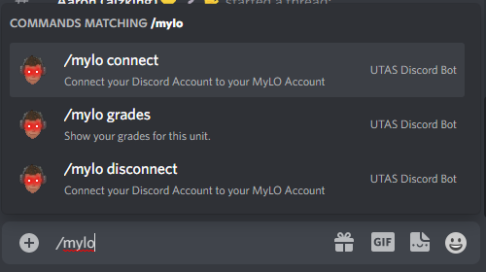
I have provided in italics additional information regarding the security issues at each step. Note that all command uses are logged by the bot, with an audit log indicating:
- Timestamp
- Invoking Discord User ID
- Command Name and arguments
- The resulting response of a command is NOT stored, since that likely contains information like grades.

Example account linking flow using /mylo connect
- User types /mylo connect or any other /mylo command
- Private message with a Discord OAuth Link is generated
  - This message is only shown to the user who typed the command
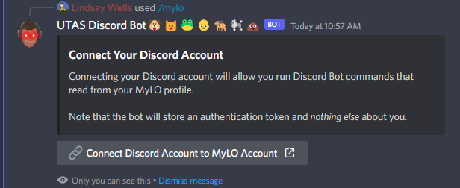

- A Discord OAuth popup appears (inside the Discord app). This is done to ensure the bot knows exactly who clicked the link.
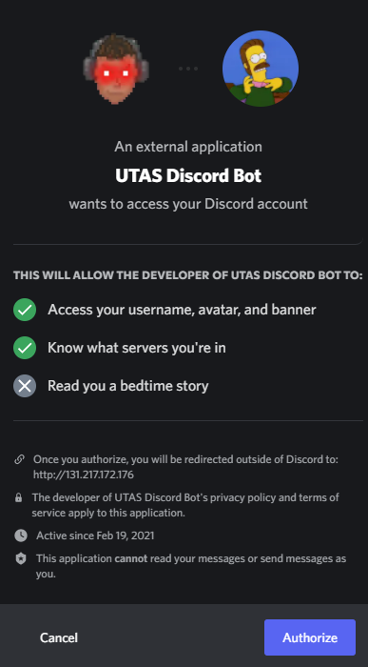
- After Discord authorization, a browser window with a MyLO OAuth login screen is shown. In this sample, we just pass through student ID because we don’t know what MyLO OAuth provides back other than token
  - The redirect from the Authorize button generated by Discord to the MyLO page contains an encrypted state payload. This payload contains:
    - The Discord message id of the original private message
    - The Discord server id where the original private message was posted
    - The Discord user id of the authenticated user
  - The server id and user id are publicly accessible to any Discord user, however the Discord message id cannot be determined by other users, and thus cannot be spoofed.
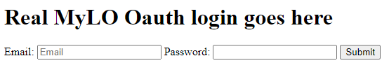
- After MyLO Oauth Completed, redirected to Bot server with token and info. At this point token and info is stored in database
  - The encrypted state payload from the previous step will be passed through the MyLO Oauth flow as with the Discord Oauth flow.
  - Upon successful login, the original private message id is cross-checked with the authenticated Discord user id
  - A tuple of [ Discord User ID, MyLO Oauth Token ] is stored in the database, nothing else is stored.
  - The Oauth token at all times remains on the server-side and is not needed by the Discord client
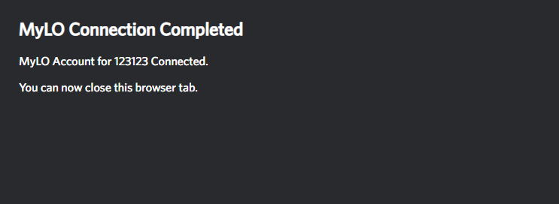
- Original private message automatically updated with a student id fetched using MyLO API to show the connection was successful.
  - All discord private messages (ephemeral messages) are not stored permanently on the Discord server chat logs, and only appear client-side for a short time (~15 minutes). They can be dismissed by the user at any time, and are irretrievable.
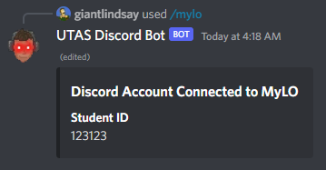

Disconnecting accounts using /mylo disconnect
- User types /mylo disconnect
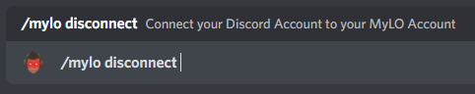
- User shown a confirmation button to disconnect
  - This message is only visible to the user
  - Only the authenticated user can press this button, there is no way for another user to spoof this button event as it goes through Discord’s servers
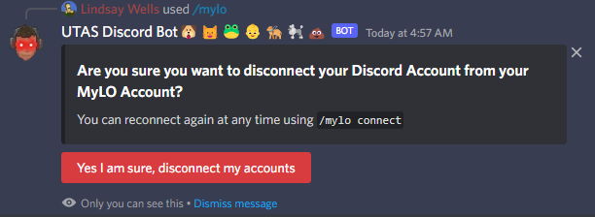
- User clicks the disconnect button and the private message automatically updates to reflect that the operation was successful.
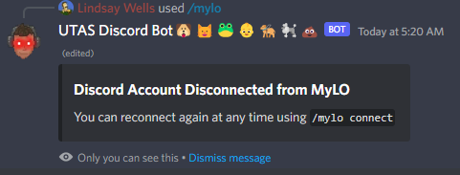

Example Mylo-enabled command: /mylo grades
- User types in /mylo grades
  - The bot checks the database for a stored oauth token for the authenticated Discord user who invoked the command.
  - There is no external interface to the bot which can request an oauth token for a given Discord ID, thus there is no way to obtain an oauth token for another user
  - The oauth token at all times remains on the server-side, and is not needed by the Discord client.
- If an oauth token is found, it is used to run the required MyLO API request, and the bot returns formatted output as a private message
  - This message is only visible to the user who ran the command
  - As before, all private (ephemeral) messages like this are not stored on Discords server chat logs
  - The MyLO API request using the Oauth token is done on the server side with tested code to ensure only the correct Oauth token is used
  - Regardless of the MyLO API request, the following safeguards are in place inherent to using Oauth:
    - Only data that the authenticated MyLO student user could access can be returned. This is further limited by the registered scopes of the application
    - The user will be authenticated with a scope to only do read-only actions, thus even if a write request was made it would return an error
  - If no oauth token is found for the authenticated Discord user, the user is prompted to link their account.
